1. Fruit

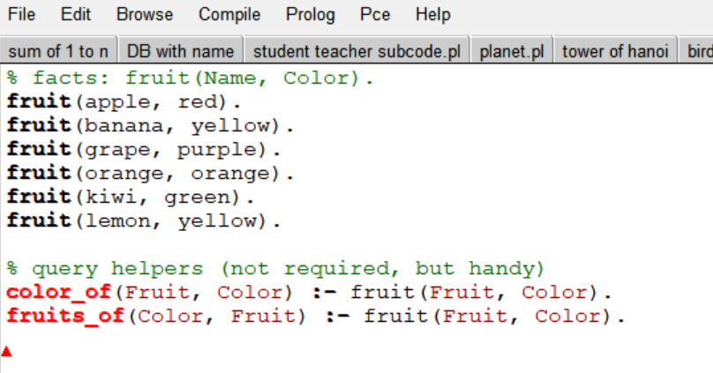

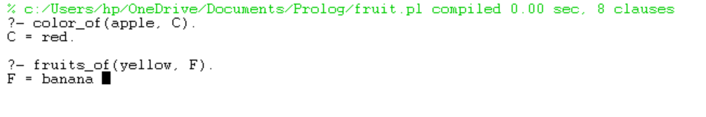

1. Implement best first search algorithm

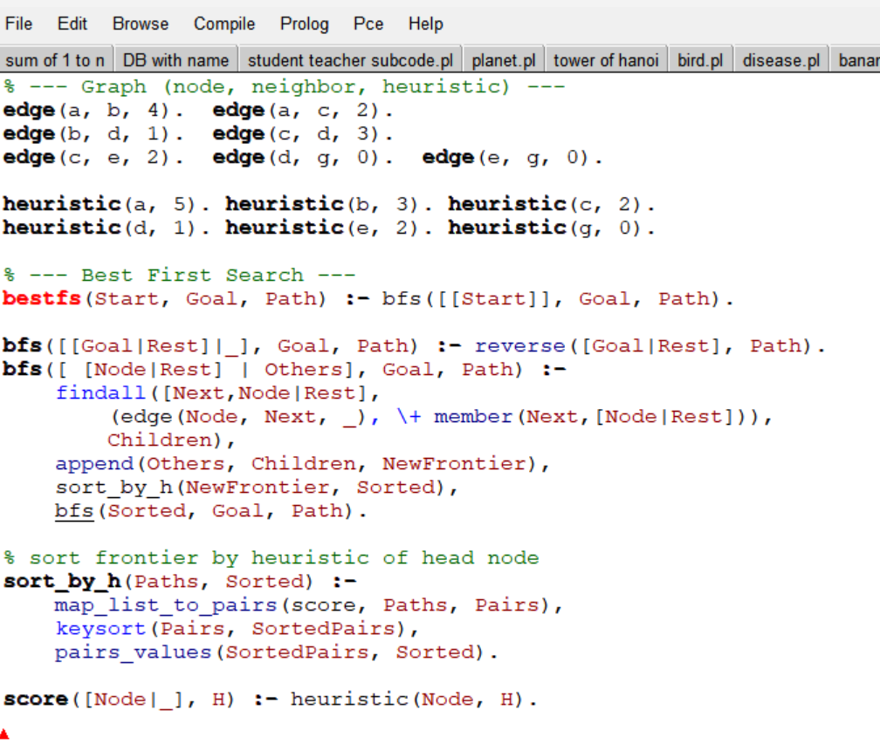

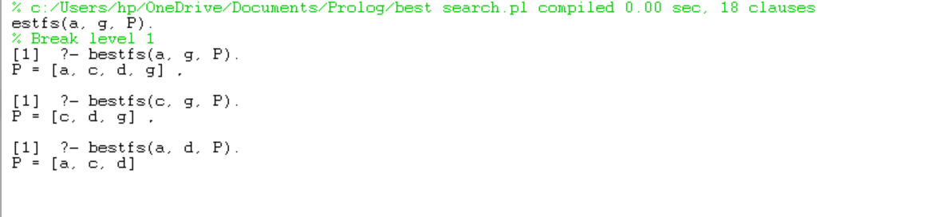

1. Medical Diagnose

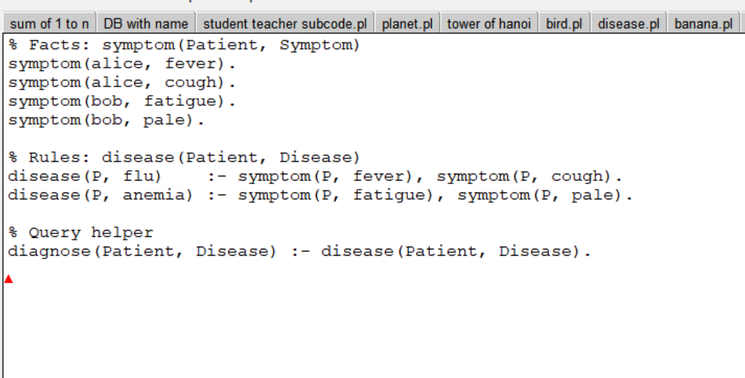

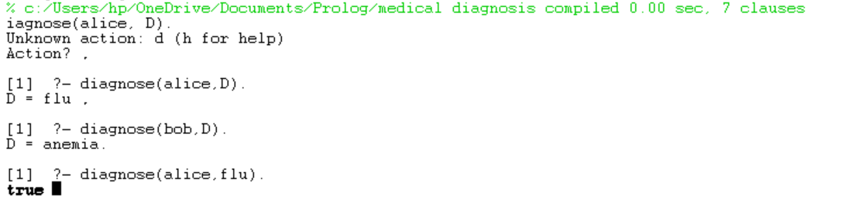

1. Write the prolog program to implement family

tree

Pam, Liz, Ann and Pat are female, while Tom,

Bob and Jim are male persons.

Using this information, define the following

relations:

•Define the “mother” relation:

•Define the “father” relation:

•Define the “grandfather” relation:

•Define the “grandmother” relation:

•Define the “sister” relation

Define the “brother” relation

